**Lest We Forget**

Thank you for attending this year’s ANZAC Day Service.

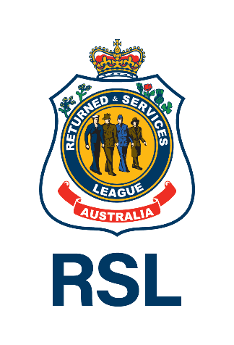

ANZAC Day

**2025**

**Order of Service**

### 25 April

### [Insert time]

# Advance Australia Fair

Australians all let us rejoice,

For we are one and free;

We’ve golden soil and wealth for toil,

Our home is girt by sea;

Our land abounds in nature’s gifts

Of beauty rich and rare;

In history’s page, let every stage

Advance Australia Fair.

In joyful strains then let us sing,

Advance Australia Fair.

# Abide with me

Abide with me; fast falls the eventide;

The darkness deepens; Lord, with me abide.

When other helpers fail and comforts flee,

Help of the helpless, O abide with me.

Swift to its close ebbs out life's little day;

Earth's joys grow dim; its glories pass away;

Change and decay in all around I see;

O thou who changest not, abide with me.

# Order of service

**Flags lowered to half-mast (if applicable)**

When first raised for the day, flags should be raised to the masthead before being lowered to half-mast.

Flags should be at half-mast for the start of the ceremony.

**Welcome and announcements**

**Mounting of catafalque party (if applicable)**

**Hymn or other music**

Common choices include Abide with Me.

**Readings (e.g. poem, prayer, story, speech)**

**Commemorative address**

Words acknowledging the reason for the service.

**Hymn or other music**

Common choices include Abide with Me.

**Prayers**

**Laying of wreaths**

**The Ode of Remembrance**

*They went with songs to the battle, they were young,*

*Straight of limb, true of eye, steady and aglow.*

*They were staunch to the end against odds uncounted;*

*They fell with their faces to the foe.*

*They shall grow not old, as we that are left grow old;*

*Age shall not weary them, nor the years condemn.*

*At the going down of the sun and in the morning*

*We will remember them.*

**Guests repeat: “We will remember them”**

**“Lest we forget”**

**The Last Post**

This bugle call was traditionally played to signal the end of a soldier’s day. At commemorations including ANZAC Day, the Last Post is sounded to herald service people who have gone to their final rest, symbolically marking the end of their duty.

**Period of silence**

It’s customary to observe one or two minutes of silence in memory of the fallen.

**The Rouse (or Reveille, at Dawn Services)**

Played only at Dawn Services, Reveille is a bright, cheerful bugle call traditionally used to rouse sleeping soldiers to duty. It symbolises an awakening in a better world for the dead and rouses the living – their respects paid to the memory of their comrades – back to duty.

Ceremonies other than Dawn Services use the Rouse – a shorter bugle call that was also used to call soldiers to their duties.

**National Anthem/s**

In Australia, if both the Australian and New Zealand National Anthems are played, the New Zealand National Anthem is played first.

**Dismounting of catafalque party (if applicable)**

**Closing remarks**

**Flags lowered or raised (if applicable)**

At the end of the ceremony, flags are lowered to half-mast until noon.

After noon, flags may be raised to the masthead.